Topic/Skill | Definition/Tips | Example  Topic: Real Life Graphs
1. Real Life Graphs | Graphs that are supposed to model some real-life situation.  The actual meaning of the values depends on the labels and units on each axis.  The gradient might have a contextual meaning.  The y-intercept might have a contextual meaning.  The area under the graph might have a contextual meaning. | A graph showing the cost of hiring a ladder for various numbers of days.  The gradient shows the cost per day. It costs £3/day to hire the ladder.  The y-intercept shows the additional cost/deposit/fixed charge (something not linked to how long the ladder is hired for). The additional cost is £7.
2. Conversion Graph | A line graph to convert one unit to another.  Can be used to convert units (eg. miles and kilometres) or currencies ($ and £)  Find the value you know on one axis, read up/across to the conversion line and read the equivalent value from the other axis. | 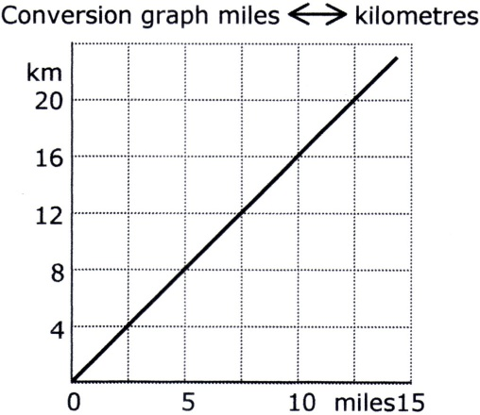  $$8 km=5 miles$$
3. Depth of Water in Containers | Graphs can be used to show how the depth of water changes as different shaped containers are filled with water at a constant rate. | 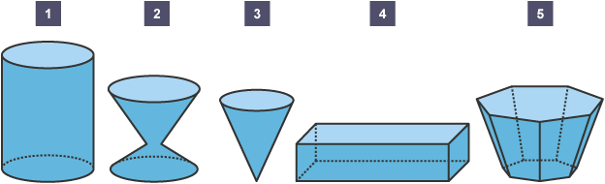  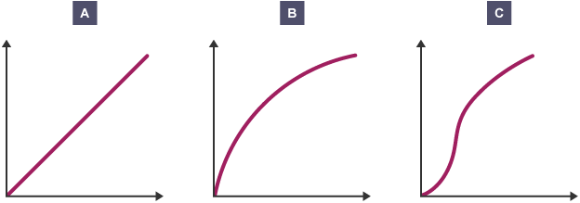

Knowledge Organiser

