Topic/Skill | Definition/Tips  Topic: Scatter Graphs | Example
1. Correlation | Correlation between two sets of data means they are connected in some way. | There is correlation between temperature and the number of ice creams sold.
2. Causality | When one variable influences another variable. | The more hours you work at a particular job (paid hourly), the higher your income from that job will be.
3. Positive Correlation | As one value increases the other value increases.
4. Negative Correlation | As one value increases the other value decreases.
5. No Correlation | There is no linear relationship between the two.
6. Strong Correlation | When two sets of data are closely linked.
7. Weak Correlation | When two sets of data have correlation, but are not closely linked.
8. Scatter Graph | A graph in which values of two variables are plotted along two axes to compare them and see if there is any connection between them. | 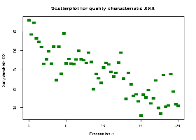
9. Line of Best Fit | A straight line that best represents the data on a scatter graph. | 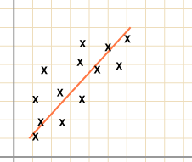
10. Outlier | A value that ‘lies outside’ most of the other values in a set of data.  An outlier is much smaller or much larger than the other values in a set of data. | 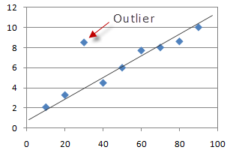
Subject: Maths

Knowledge Organiser

