Topic/Skill | Definition/Tips  Topic: Vectors | Example
1. Translation | Translate means to move a shape.  The shape does not change size or orientation. | 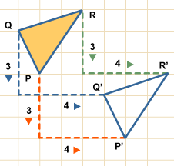
2. Vector Notation | A vector can be written in 3 ways:  a or $\vec{AB}$ or $\left(\begin{matrix}1 \\ 3\end{matrix}\right)$
3. Column Vector | In a column vector, the top number moves left (-) or right (+) and the bottom number moves up (+) or down (-) | $\left(\begin{matrix}2 \\ 3\end{matrix}\right)$ means ‘2 right, 3 up’  $\left(\begin{matrix}-1 \\ -5\end{matrix}\right)$ means ‘1 left, 5 down’
4. Vector | A vector is a quantity represented by an arrow with both direction and magnitude.  $$\vec{AB}=-\vec{BA}$$
5. Magnitude | Magnitude is defined as the length of a vector. | 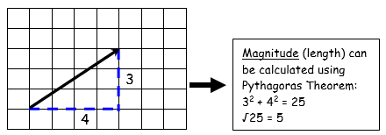
6. Equal Vectors | If two vectors have the same magnitude and direction, they are equal. | 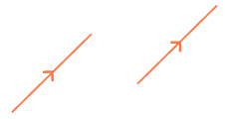
7. Parallel Vectors | Parallel vectors are multiples of each other. | 2a+b and 4a+2b are parallel as they are multiple of each other.  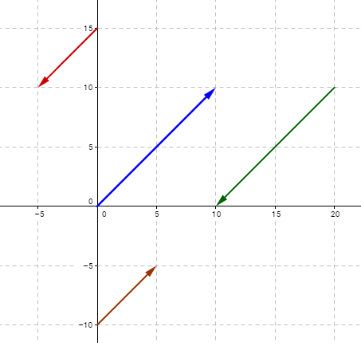
8. Collinear Vectors | Collinear vectors are vectors that are on the same line.  To show that two vectors are collinear, show that one vector is a multiple of the other (parallel) AND that both vectors share a point. | 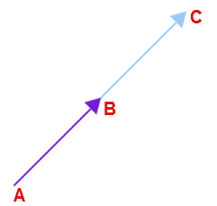
9. Resultant Vector | The resultant vector is the vector that results from adding two or more vectors together.  The resultant can also be shown by lining up the head of one vector with the tail of the other. | if a = $\left({4 \atop 4}\right)$ and b = $\left({2 \atop -2}\right)$  then a + b = $\left({4 \atop 4}\right)$ + $\left({2 \atop -2}\right)$ = $\left({6 \atop 2}\right)$  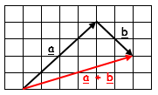
10. Scalar of a Vector | A scalar is the number we multiply a vector by. | 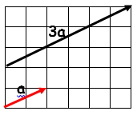  Example:  3a + 2b =  = 3$\left({2 \atop 1}\right)$ + 2$\left({4 \atop -1}\right)$  = $\left({6 \atop 3}\right)$ + $\left({8 \atop -2}\right)$  = $\left({14 \atop 1}\right)$
11. Vector Geometry |  | 