Topic/Skill | Definition/Tips | Example  Topic: Histograms and Cumulative Frequency
1. Histograms | A visual way to display frequency data using bars.  Bars can be unequal in width.  Histograms show frequency density on the y-axis, not frequency.  $$Frequency Density= \frac{Frequency}{Class Width}$$  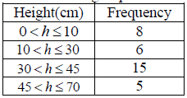 | 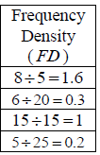  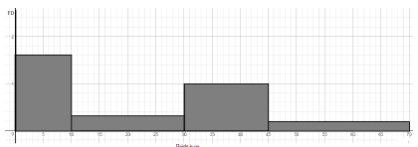
2. Interpreting Histograms | The area of the bar is proportional to the frequency of that class interval.  $$Frequency=Freq Density ×Class Width$$ | A histogram shows information about the heights of a number of plants. 4 plants were less than 5cm tall. Find the number of plants more than 5cm tall.  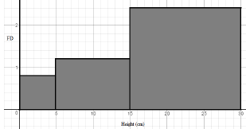  Above 5cm:  1.2 x 10 + 2.4 x 15 = 12 + 36 = 48
3. Cumulative Frequency | Cumulative Frequency is a running total.  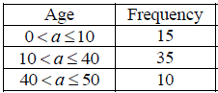 | 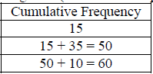
4. Cumulative Frequency Diagram | A cumulative frequency diagram is a curve that goes up. It looks a little like a stretched-out S shape.  Plot the cumulative frequencies at the end-point of each interval. | 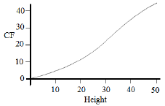
5. Quartiles from Cumulative Frequency Diagram | Lower Quartile (Q1): 25% of the data is less than the lower quartile.  Median (Q2): 50% of the data is less than the median.  Upper Quartile (Q3): 75% of the data is less than the upper quartile.  Interquartile Range (IQR): represents the middle 50% of the data. | 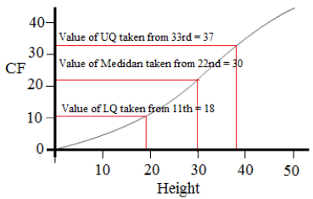  $$IQR=37-18=19$$
6. Hypothesis | A statement that might be true, which can be tested. | Hypothesis: ‘Large dogs are better at catching tennis balls than small dogs’.  We can test this hypothesis by having hundreds of different sized dogs try to catch tennis balls.

Knowledge Organiser

