Topic/Skill | Definition/Tips  Topic: Equation of a Circle and Tangent | Example
1. Equation of a Circle | The equation of a circle, centre (0,0), radius r, is:  $$x^{2}+y^{2}=r^{2}$$ | 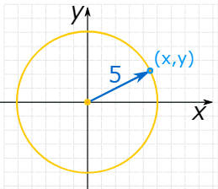  $$x^{2}+y^{2}=25$$
2. Tangent | A straight line that touches a circle at exactly one point, never entering the circle’s interior.  A radius is perpendicular to a tangent at the point of contact. | 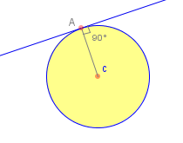
3. Gradient | Gradient is another word for slope.  $$G= \frac{Rise}{Run}= \frac{Change in y}{Change in x}= \frac{y_{2}-y_{1}}{x_{2}-x_{1}}$$ | 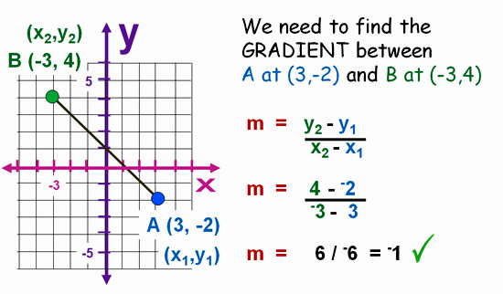
4. Circle Theorem 5 | A tangent is perpendicular to the radius at the point of contact.  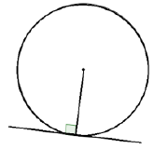 | 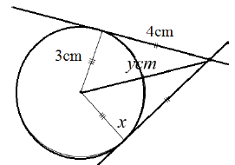  $y=5cm$(Pythagoras’ Theorem)
Subject: Maths

Knowledge Organiser

