Topic/Skill | Definition/Tips | Example  Topic: Area Under Graph and Gradient of Curve
1. Area Under a Curve | To find the area under a curve, split it up into simpler shapes – such as rectangles, triangles and trapeziums – that approximate the area. | 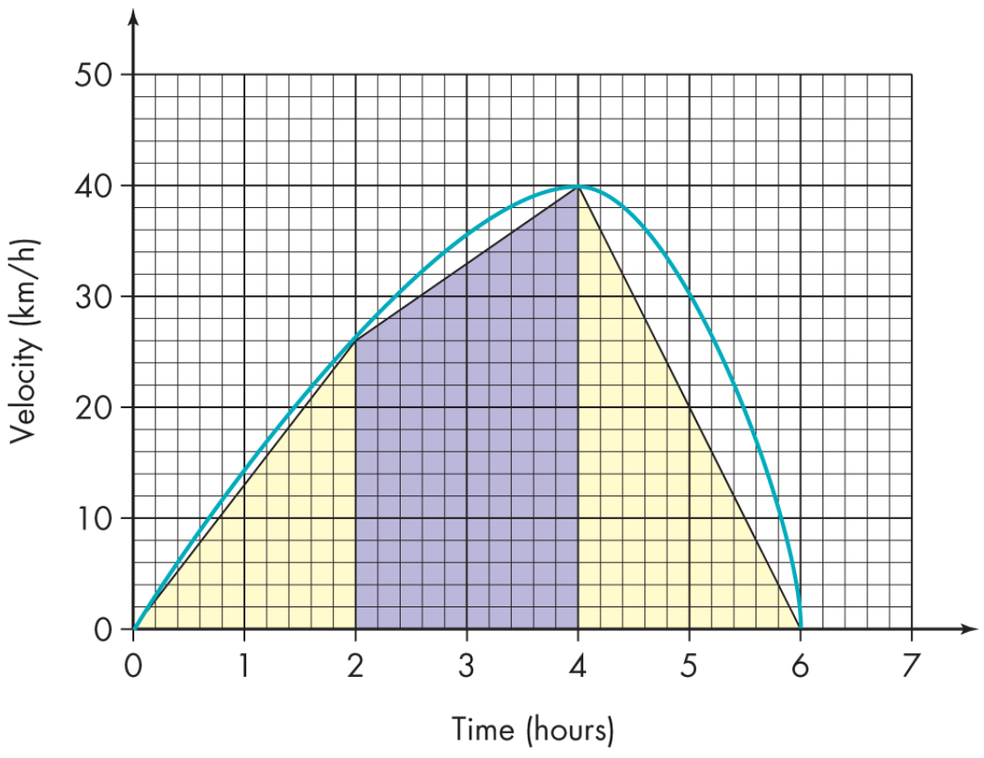
2. Tangent to a Curve | A straight line that touches a curve at exactly one point. | 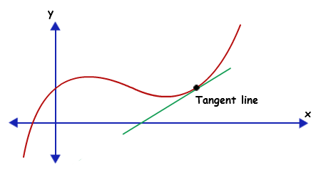
3. Gradient of a Curve | The gradient of a curve at a point is the same as the gradient of the tangent at that point.  1. Draw a tangent carefully at the point.  2. Make a right-angled triangle.  3. Use the measurements on the axes to calculate the rise and run (change in y and change in x)  4. Calculate the gradient. | 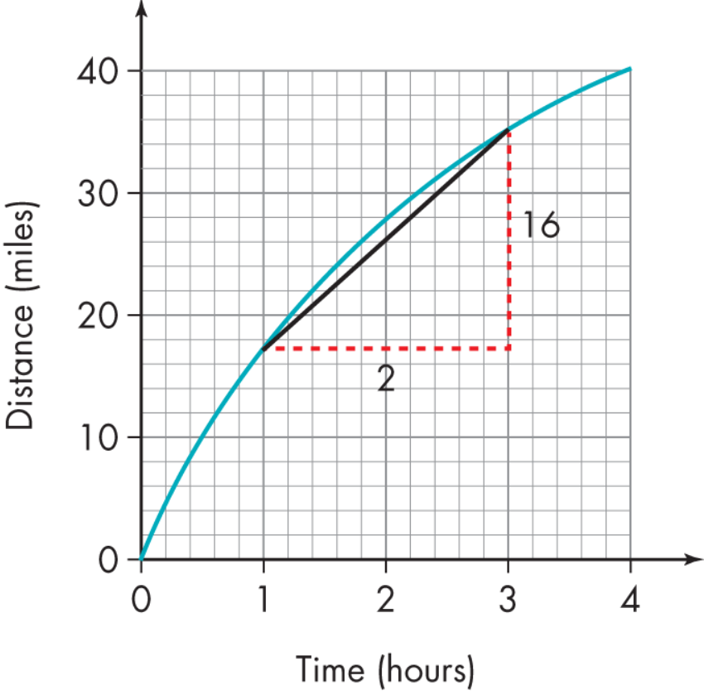  $$Gradient=\frac{Change in y}{Change in x}$$  $$=\frac{16}{2}=8$$
4. Rate of Change | The rate of change at a particular instant in time is represented by the gradient of the tangent to the curve at that point. | 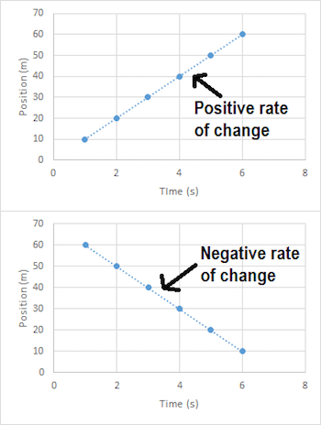
5. Distance-Time Graphs | You can find the speed from the gradient of the line (Distance ÷ Time)  The steeper the line, the quicker the speed.  A horizontal line means the object is not moving (stationary). | 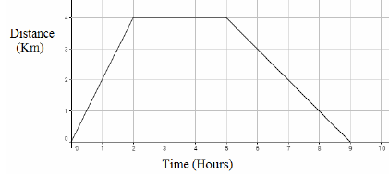
6. Velocity-Time Graphs | You can find the acceleration from the gradient of the line (Change in Velocity ÷ Time)  The steeper the line, the quicker the acceleration.  A horizontal line represents no acceleration, meaning a constant velocity.  The area under the graph is the distance. | 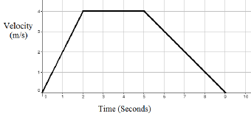

Knowledge Organiser

