Topic/Skill | Definition/Tips  Topic: Graphs and Graph Transformations | Example
1. Coordinates | Written in pairs. The first term is the x-coordinate (movement across). The second term is the y-coordinate (movement up or down) | 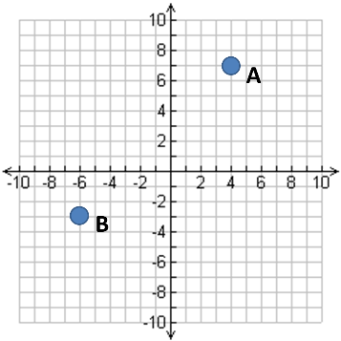  A: (4,7)  B: (-6,-3)
2. Linear Graph | Straight line graph.  The equation of a linear graph can contain an x-term, a y-term and a number. | Example:  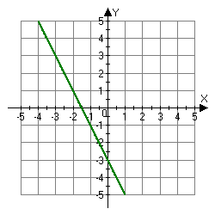  Other examples:  $x=y$  $y=4$  $x=-2$  $y=2x-7$  $y+x=10$  $2y-4x=12$
3. Quadratic Graph | A ‘U-shaped’ curve called a parabola.  The equation is of the form  $y=ax^{2}+bx+c$, where $a$, $b$ and $c$ are numbers, $a≠0$.  If $a<0$, the parabola is upside down. | 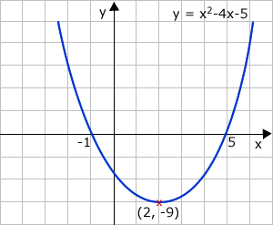
4. Cubic Graph | The equation is of the form $y={ax}^{3}+k$, where $k$ is an number.  If $a>0$, the curve is increasing.  If $a<0$, the curve is decreasing.
5. Reciprocal Graph | The equation is of the form $y=\frac{A}{x}$, where $A$ is a number and $x≠0$.  The graph has asymptotes on the x-axis and y-axis. | 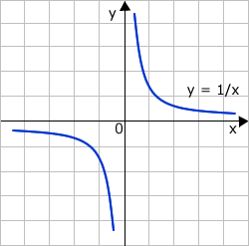
6. Asymptote | A straight line that a graph approaches but never touches.  Subject: Maths | 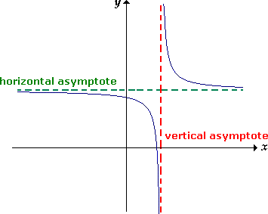
7. Exponential Graph | The equation is of the form $y=a^{x}$, where $a$is a number called the base.  If $a>1$ the graph increases.  If $0<a<1$, the graph decreases.  The graph has an asymptote which is the x-axis.
8. $y=\sin{x}$ | Key Coordinates:  $$\left(0,0\right), \left(90,1\right), \left(180,0\right), \left(270,-1\right), (360,0)$$  $y$ is never more than 1 or less than -1.  Pattern repeats every 360°. | 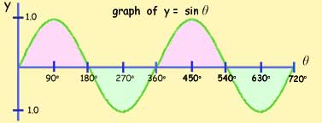
9. $y=\cos{x}$ | Key Coordinates:  $$\left(0,1\right), \left(90,0\right), \left(180,-1\right), \left(270,0\right), (360,1)$$  $y$ is never more than 1 or less than -1.  Pattern repeats every 360°. | 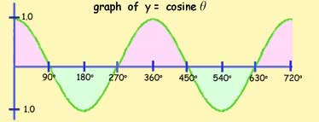
10. $y=\tan{x}$ | Key Coordinates:  $$\left(0,0\right), \left(45,1\right), \left(135,-1\right), \left(180,0\right),$$  $$\left(225,1\right), \left(315,-1\right), (360,0)$$  Asymptotes at $x=90$ and $x=270$  Pattern repeats every 360°. | 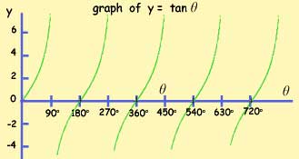
11. $f\left(x\right)+a$ | Vertical translation up a units. $\left(\begin{matrix}0 \\ a\end{matrix}\right)$ | 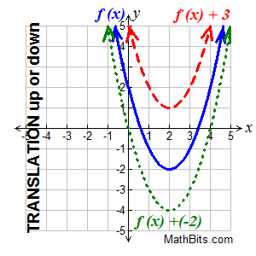
12. $f(x+a)$ | Horizontal translation left a units. $\left(\begin{matrix}-a \\ 0\end{matrix}\right)$ | 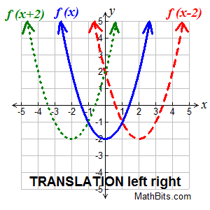
13. $-f(x)$ | Reflection over the x-axis. | 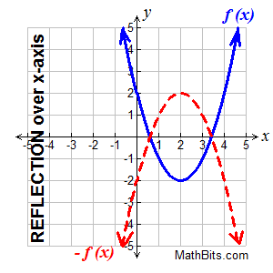
14. $f(-x)$ | Reflection over the y-axis. | 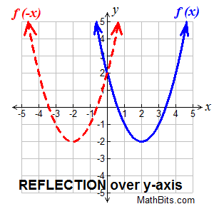

Knowledge Organiser

