Topic/Skill | Definition/Tips  Topic: Functions | Example
1. Function Machine | Takes an input value, performs some operations and produces an output value. | 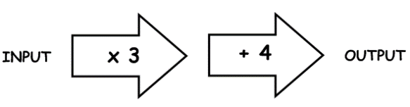
2. Function | A relationship between two sets of values. | $f\left(x\right)=3x^{2}-5$  ‘For any input value, square the term, then multiply by 3, then subtract 5’.
3. Function notation | $f(x)$  $x$is the input value  $f(x)$ is the output value. | $$f\left(x\right)=3x+11$$  Suppose the input value is $x=5$  The output value is $f\left(5\right)=3×5+11=26$
4. Inverse function | $f^{-1}(x)$  A function that performs the opposite process of the original function.  1. Write the function as $y=f(x)$  2. Rearrange to make $x$ the subject.  3. Replace the $y$with $x$ and the $x$with $f^{-1}\left(x\right)$ | $f\left(x\right)={(1-2x)}^{5}$. Find the inverse.  $y={(1-2x)}^{5}$  $\sqrt[5]{y}=1-2x$  $1-\sqrt[5]{y}=2x$  $\frac{1-\sqrt[5]{y}}{2}=x$  $$f^{-1}\left(x\right)=\frac{1-\sqrt[5]{x}}{2}$$
5. Composite function | A combination of two or more functions to create a new function.  $fg(x)$ is the composite function that substitutes the function $g\left(x\right)$ into the function $f\left(x\right).$  $fg(x)$ means ‘do g first, then f’  $gf(x)$ means ‘do f first, then g’ | $f\left(x\right)=5x-3$, $g\left(x\right)=\frac{1}{2}x+1$  What is $fg\left(4\right)$?  $$g\left(4\right)=\frac{1}{2}×4+1=3$$  $$f\left(3\right)=5×3-3=12=fg\left(4\right)$$  What is $fg(x)$?  $$fg\left(x\right)=5\left(\frac{1}{2}x+1\right)-3=\frac{5}{2}x+2$$
Subject: Maths

Knowledge Organiser

