Topic/Skill | Definition/Tips | Example  Topic: Probability (Trees and Venns)
1. Tree Diagrams | Tree diagrams show all the possible outcomes of an event and calculate their probabilities.  All branches must add up to 1 when adding downwards.  This is because the probability of something not happening is 1 minus the probability that it does happen.  Multiply going across a tree diagram.  Add going down a tree diagram. | 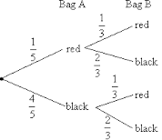
2. Independent Events | The outcome of a previous event does not influence/affect the outcome of a second event. | An example of independent events could be replacing a counter in a bag after picking it.
3. Dependent Events | The outcome of a previous event does influence/affect the outcome of a second event. | An example of dependent events could be not replacing a counter in a bag after picking it.  ‘Without replacement’
4. Probability Notation | P(A) refers to the probability that event A will occur.  P(A’) refers to the probability that event A will not occur.  P(A $∪$B) refers to the probability that event A or B or both will occur.  P(A $∩$B) refers to the probability that both events A and B will occur. | P(Red Queen) refers to the probability of picking a Red Queen from a pack of cards.  P(Blue’) refers to the probability that you do not pick Blue.  P(Blonde $∪$ Right Handed) refers to the probability that you pick someone who is Blonde or Right Handed or both.  P(Blonde $∩$ Right Handed) refers to the probability that you pick someone who is both Blonde and Right Handed.
5. Venn Diagrams | A Venn Diagram shows the relationship between a group of different things and how they overlap.  You may be asked to shade Venn Diagrams as shown below and to the right.  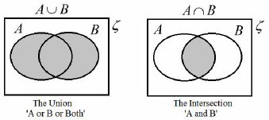 | 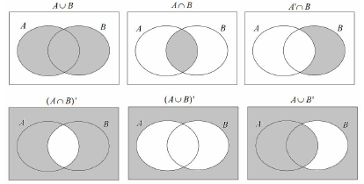
6. Venn Diagram Notation | $∈$ means ‘element of a set’ (a value in the set)  { } means the collection of values in the set.  $ξ$means the ‘universal set’ (all the values to consider in the question)  A’ means ‘not in set A’ (called complement)  A $∪$B means ‘A or B or both’ (called Union)  A $∩$B means ‘A and B (called Intersection) | Set A is the even numbers less than 10.  A = {2, 4, 6, 8}  Set B is the prime numbers less than 10.  B = {2, 3, 5, 7}  A $∪$B = {2, 3, 4, 5, 6, 7, 8}  A $∩$B = {2}
7. AND rule for Probability | When two events, A and B, are independent:  $$P\left(A and B\right)=P(A)×P(B)$$ | What is the probability of rolling a 4 and flipping a Tails?  $$P\left(4 and Tails\right)=P\left(4\right)×P\left(Tails\right)$$  $$=\frac{1}{6}×\frac{1}{2}=\frac{1}{12}$$
8. OR rule for Probability | When two events, A and B, are mutually exclusive:  $$P\left(A or B\right)=P\left(A\right)+P(B)$$ | What is the probability of rolling a 2 or rolling a 5?  $$P\left(2 or 5\right)=P\left(2\right)+P\left(5\right)$$  $$=\frac{1}{6}+\frac{1}{6}=\frac{2}{6}=\frac{1}{3}$$
9. Conditional Probability | The probability of an event A happening, given that event B has already happened.  With conditional probability, check if the numbers on the second branches of a tree diagram changes. For example, if you have 4 red beads in a bag of 9 beads and pick a red bead on the first pick, then there will be 3 red beads left out of 8 beads on the second pick. | 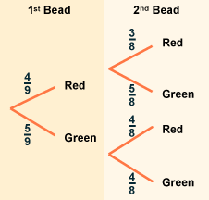

Knowledge Organiser

