Topic/Skill | Definition/Tips | Example  Topic: Trigonometry
1. Exact Values for Angles in Trigonometry | 0° 30° 45° 60° 90°  sin 0 $$\frac{1}{2}$$ $$\frac{\sqrt{2}}{2}$$ $$\frac{\sqrt{3}}{2}$$ 1  cos 1 $$\frac{\sqrt{3}}{2}$$ $$\frac{\sqrt{2}}{2}$$ $$\frac{1}{2}$$ 0  tan 0 $$\frac{1}{\sqrt{3}}$$ 1 $$\sqrt{3}$$ ---- | 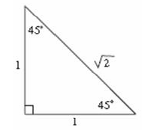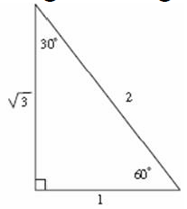
2. Sine Rule | Use with non right angle triangles.  Use when the question involves 2 sides and 2 angles.  For missing side:  $$\frac{a}{\sin{A}}=\frac{b}{\sin{B}}$$  For missing angle:  $$\frac{\sin{A}}{a}=\frac{\sin{B}}{b}$$  There is an ambiguous case (where there are two potential answers)  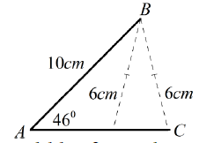  To find the two angles, use sine to find one, and then subtract your answer from 180 to find the other answer. | 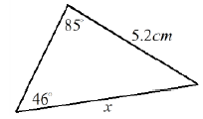  $$\frac{x}{\sin{85}}=\frac{5.2}{\sin{46}}$$  $$x=\frac{5.2×\sin{85}}{\sin{46}}=3.75cm$$  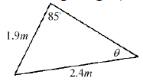  $$\frac{\sin{θ}}{1.9}=\frac{\sin{85}}{2.4}$$  $$\sin{θ}=\frac{1.9×\sin{85}}{2.4}=0.789$$  $$θ=\sin^{-1}\left(0.789\right)=52.1°$$
3. Cosine Rule | Use with non right angle triangles.  Use when the question involves 3 sides and 1 angle.  For missing side:  $$a^{2}=b^{2}+c^{2}-2bccosA$$  For missing angle:  $$\cos{A=\frac{b^{2}+c^{2}-a^{2}}{2bc}}$$ | 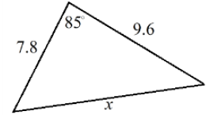  $$x^{2}={9.6}^{2}+{7.8}^{2}-(2×9.6×7.8×\cos{85)}$$  $$x=11.8$$  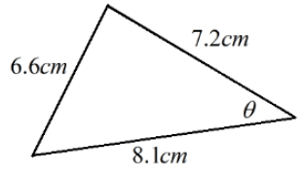  $$\cos{θ=\frac{{7.2}^{2}+{8.1}^{2}-{6.6}^{2}}{2×7.2×8.1}}$$  $$θ=50.7°$$
4. Graphs of Trigonometric Functions | 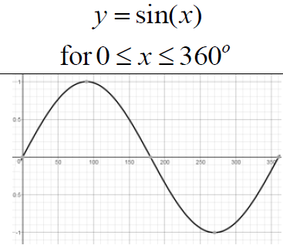  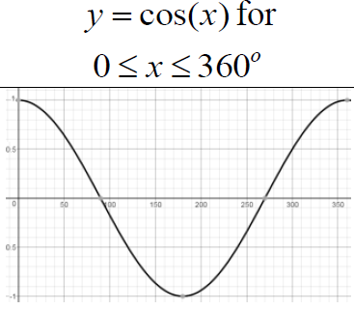  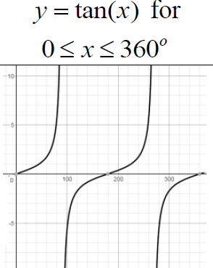 | 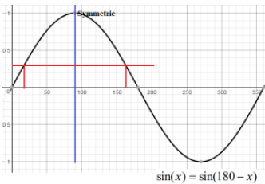  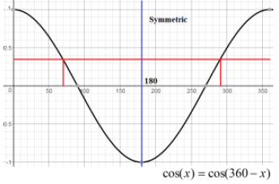  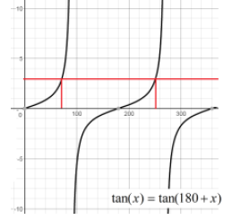
5. Area of a Triangle | Use when given the length of two sides and the included angle.  $$Area of a Triangle=\frac{1}{2}ab\sin{C}$$ | 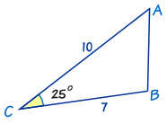  $$A=\frac{1}{2}ab\sin{C}$$  $$A=\frac{1}{2}×7×10×\sin{25}$$  $$A=14.8$$

Knowledge Organiser

