Topic/Skill | Definition/Tips | Example  Topic: Inequalities
1. Inequality | An inequality says that two values are not equal.  $a≠b$ means that a is not equal to b. | $$7≠3$$  $$x≠0$$
2. Inequality symbols | $x>2$ means x is greater than 2  $x<3$ means x is less than 3  $x≥1$ means x is greater than or equal to 1  $x≤6$means x is less than or equal to 6 | State the integers that satisfy  $$-2<x≤4.$$  -1, 0, 1, 2, 3, 4
3. Inequalities on a Number Line | Inequalities can be shown on a number line.  Open circles are used for numbers that are less than or greater than $(<or>)$  Closed circles are used for numbers that are less than or equal or greater than or equal $(≤or≥)$ | 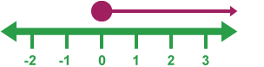$x≥0$  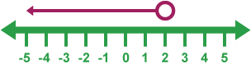$x<2$  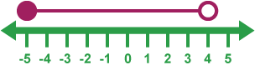$-5≤x<4$
4. Graphical Inequalities | Inequalities can be represented on a coordinate grid.  If the inequality is strict ($x>2$) then use a dotted line.  If the inequality is not strict ($x≤6$) then use a solid line.  Shade the region which satisfies all the inequalities. | Shade the region that satisfies:  $$y>2x, x>1 and y≤3$$  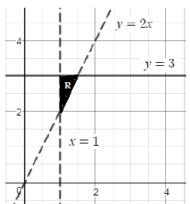
5. Quadratic Inequalities | Sketch the quadratic graph of the inequality.  If the expression is $>or≥$ then the answer will be above the x-axis.  If the expression is $<or≤$ then the answer will be below the x-axis.  Look carefully at the inequality symbol in the question.  Look carefully if the quadratic is a positive or negative parabola. | Solve the inequality $x^{2}-x-12<0$  Sketch the quadratic:  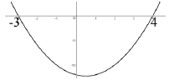  The required region is below the x-axis, so the final answer is:  $$-3<x<4$$  If the question had been $>0$, the answer would have been:  $$x<-3 or x>4$$
6. Set Notation | A set is a collection of things, usually numbers, denoted with brackets $\{ \}$  $\left\{x \right| x≥7\}$ means ‘the set of all x’s, such that x is greater than or equal to 7’  The ‘x’ can be replaced by any letter.  Some people use ‘:’ instead of ‘|’ | $\{3, 6, 9\}$ is a set.  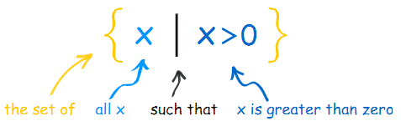  $$\{x : -2≤x<5\}$$

Knowledge Organiser

