Topic/Skill | Definition/Tips | Example  Topic: Circle Theorems
Circle Theorem 1 | Angles in a semi-circle have a right angle at the circumference.  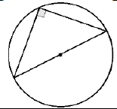 | 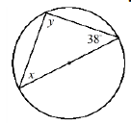  $$y=90°$$  $$x=180-90-38=52°$$
Circle Theorem 2 | Opposite angles in a cyclic quadrilateral add up to 180°.  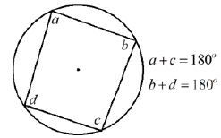 | 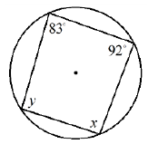  $$x=180-83=97°$$  $$y=180-92=88°$$
Circle Theorem 3 | The angle at the centre is twice the angle at the circumference.  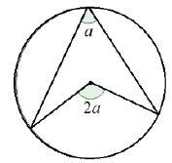 | 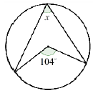  $$x=104÷2=52°$$
Circle Theorem 4 | Angles in the same segment are equal.  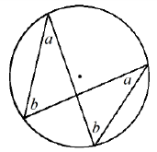 | 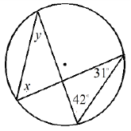  $$x=42°$$  $$y=31°$$
Circle Theorem 5 | A tangent is perpendicular to the radius at the point of contact.  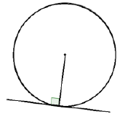 | 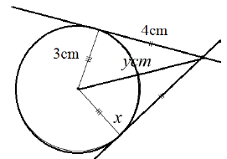  $y=5cm$(Pythagoras’ Theorem)
Circle Theorem 6 | Tangents from an external point at equal in length.  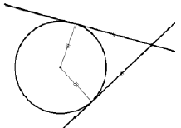 | $$x=90°$$
Circle Theorem 7 | Alternate Segment Theorem  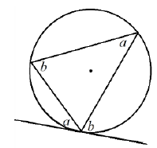 | 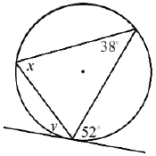  $$x=52°$$  $$y=38°$$

Knowledge Organiser

