Topic/Skill | Definition/Tips | Example  Topic: Volume
1. Volume | Volume is a measure of the amount of space inside a solid shape.  Units: $mm^{3}, cm^{3},m^{3}$ etc.
2. Volume of a Cube/Cuboid | $$V=Length×Width×Height$$  $$V=L×W×H$$  You can also use the Volume of a Prism formula for a cube/cuboid.
3. Prism | A prism is a 3D shape whose cross section is the same throughout. | 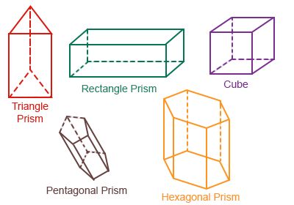
4. Cross Section | The cross section is the shape that continues all the way through the prism. | 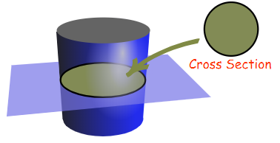
5. Volume of a Prism | $$V= Area of Cross Section×Length$$  $$V=A×L$$ | 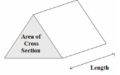
6. Volume of a Cylinder | $$V=πr^{2}h$$ | 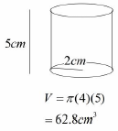
7. Volume of a Cone | $$V=\frac{1}{3}πr^{2}h$$ | 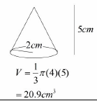
8. Volume of a Pyramid | $$Volume= \frac{1}{3}Bh$$  where B = area of the base | 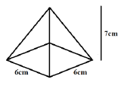  $$V=\frac{1}{3}×6×6×7=84{cm}^{3}$$
9. Volume of a Sphere | $$V=\frac{4}{3}πr^{3}$$  Look out for hemispheres – just halve the volume of a sphere. | Find the volume of a sphere with diameter 10cm.  $$V=\frac{4}{3}π{(5)}^{3}=\frac{500π}{3}{cm}^{3}$$
10. Frustums | A frustum is a solid (usually a cone or pyramid) with the top removed.  Find the volume of the whole shape, then take away the volume of the small cone/pyramid removed at the top. | 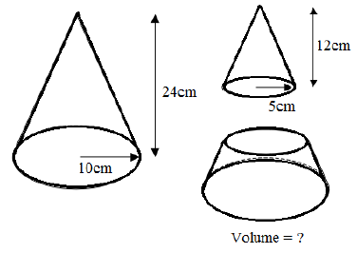  Topic: Geometry and Measures (H)  $$V=\frac{1}{3}π{\left(10\right)}^{2}\left(24\right)-\frac{1}{3}π{\left(5\right)}^{2}\left(12\right)=700π{cm}^{3}$$

Knowledge Organiser

