Topic/Skill | Definition/Tips | Example  Topic: 2D Representations of 3D Shapes
1. Net | A pattern that you can cut and fold to make a model of a 3D shape. | 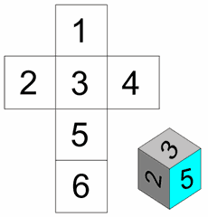
2. Properties of Solids | Faces = flat surfaces  Edges = sides/lengths  Vertices = corners | A cube has 6 faces, 12 edges and 8 vertices.  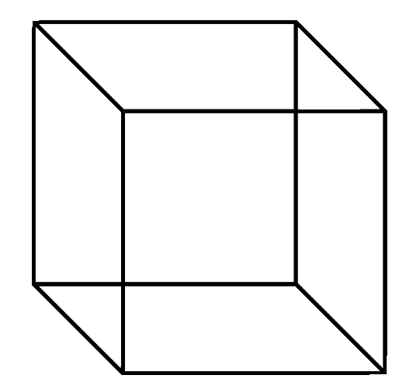
3. Plans and Elevations | This takes 3D drawings and produces 2D drawings.  Plan View: from above  Side Elevation: from the side  Front Elevation: from the front | 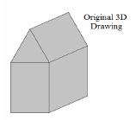  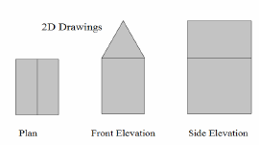
4. Isometric Drawing | A method for visually representing 3D objects in 2D.

Knowledge Organiser

