Topic/Skill | Definition/Tips | Example  Topic: Right Angled Trigonometry
1. Trigonometry | The study of triangles.
2. Hypotenuse | The longest side of a right-angled triangle.  Is always opposite the right angle. | 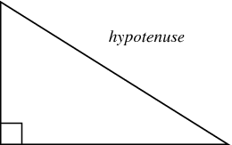
3. Adjacent | Next to | 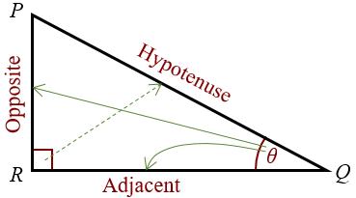
4. Trigonometric Formulae | Use SOHCAHTOA.  $$\sin{θ}=\frac{O}{H}$$  $$\cos{θ}=\frac{A}{H}$$  $$\tan{θ}=\frac{O}{A}$$  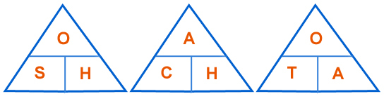  When finding a missing angle, use the ‘inverse’ trigonometric function by pressing the ‘shift’ button on the calculator. | 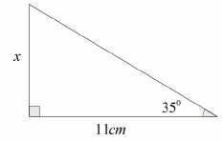  Use ‘Opposite’ and ‘Adjacent’, so use ‘tan’  $$\tan{35=}\frac{x}{11}$$  $$x=11\tan{35}=7.70cm$$  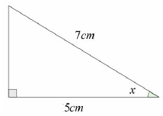  Use ‘Adjacent’ and ‘Hypotenuse’, so use ‘cos’  $$\cos{x}=\frac{5}{7}$$  $$x=\cos^{-1}\left(\frac{5}{7}\right)=44.4°$$
5. 3D Trigonometry | Find missing lengths by identifying right angled triangles.  You will often have to find a missing length you are not asked for before finding the missing length you are asked for. | 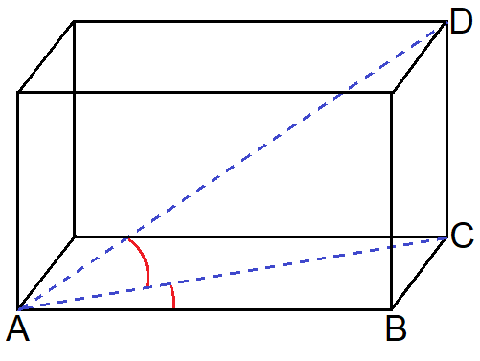

Knowledge Organiser

