Topic/Skill | Definition/Tips | Example  Topic: Circumference and Area
1. Circle | A circle is the locus of all points equidistant from a central point.
2. Parts of a Circle | Radius – the distance from the centre of a circle to the edge  Diameter – the total distance across the width of a circle through the centre.  Circumference – the total distance around the outside of a circle  Chord – a straight line whose end points lie on a circle  Tangent – a straight line which touches a circle at exactly one point  Arc – a part of the circumference of a circle  Sector – the region of a circle enclosed by two radii and their intercepted arc  Segment – the region bounded by a chord and the arc created by the chord | 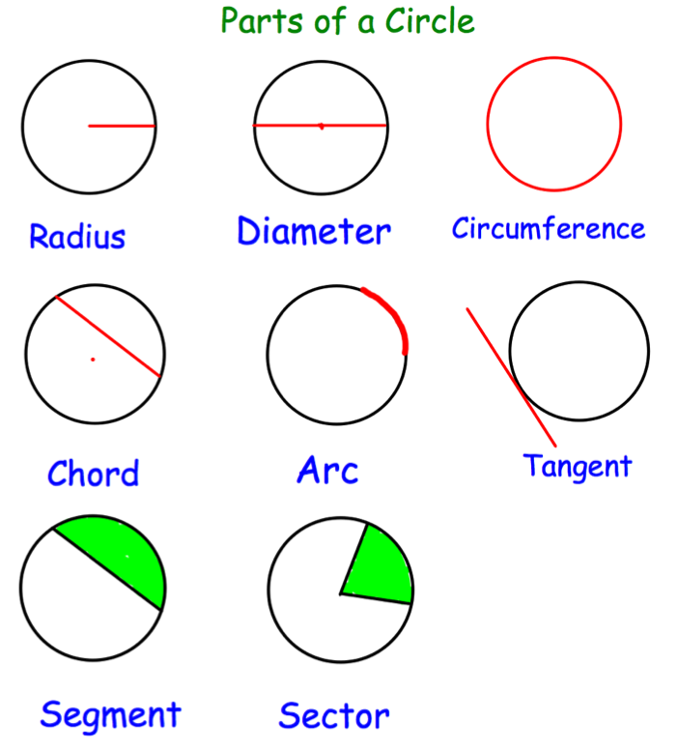
3. Area of a Circle | $A=πr^{2}$ which means ‘pi x radius squared’. | If the radius was 5cm, then:  $$A=π×5^{2}=78.5{cm}^{2}$$
4. Circumference of a Circle | $C=πd$ which means ‘pi x diameter’ | If the radius was 5cm, then:  $$C=π×10=31.4cm$$
5. $π$ (‘pi’) | Pi is the circumference of a circle divided by the diameter.  $$π≈3.14$$ | 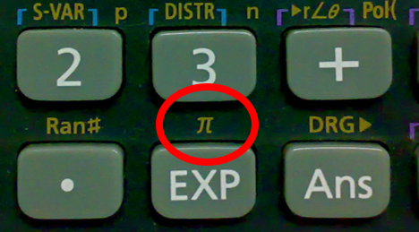
6. Arc Length of a Sector | The arc length is part of the circumference.  Take the angle given as a fraction over 360° and multiply by the circumference. | Arc Length = $\frac{115}{360}×π×8=8.03cm$  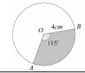
7. Area of a Sector | The area of a sector is part of the total area.  Take the angle given as a fraction over 360° and multiply by the area. | Area = $\frac{115}{360}×π×4^{2}=16.1{cm}^{2}$
8. Surface Area of a Cylinder | Curved Surface Area = $πdh$ or $2πrh$  Total SA = $2πr^{2}+πdh$ or $2πr^{2}+2πrh$ | 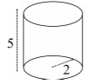  $$Total SA=2π{(2)}^{2}+π\left(4\right)\left(5\right)=28π$$
9. Surface Area of a Cone | Curved Surface Area = $πrl$  where $l=slant height$  Total SA = $πrl+ πr^{2}$  You may need to use Pythagoras’ Theorem to find the slant height | 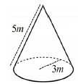  $$Total SA= π\left(3\right)\left(5\right)+π{(3)}^{2}=24π$$
10. Surface Area of a Sphere | $$SA=4πr^{2}$$  Look out for hemispheres – halve the SA of a sphere and add on a circle $(πr^{2})$ | Find the surface area of a sphere with radius 3cm.  $$SA=4π{(3)}^{2}=36π{cm}^{2}$$

Knowledge Organiser

