Topic/Skill | Definition/Tips | Example  Topic: Loci and Constructions
1. Parallel | Parallel lines never meet.
2. Perpendicular | Perpendicular lines are at right angles. There is a 90° angle between them.
3. Vertex | A corner or a point where two lines meet.
4. Angle Bisector | Angle Bisector: Cuts the angle in half.  1. Place the sharp end of a pair of compasses on the vertex.  2. Draw an arc, marking a point on each line.  3. Without changing the compass put the compass on each point and mark a centre point where two arcs cross over.  4. Use a ruler to draw a line through the vertex and centre point. | 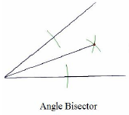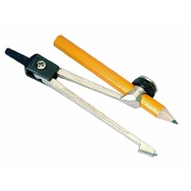
5. Perpendicular Bisector | Perpendicular Bisector: Cuts a line in half and at right angles.  1. Put the sharp point of a pair of compasses on A.  2. Open the compass over half way on the line.  3. Draw an arc above and below the line.  4. Without changing the compass, repeat from point B.  5. Draw a straight line through the two intersecting arcs. | 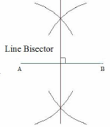
6. Perpendicular from an External Point | The perpendicular distance from a point to a line is the shortest distance to that line.  1. Put the sharp point of a pair of compasses on the point.  2. Draw an arc that crosses the line twice.  3. Place the sharp point of the compass on one of these points, open over half way and draw an arc above and below the line.  4. Repeat from the other point on the line.  5. Draw a straight line through the two intersecting arcs. | 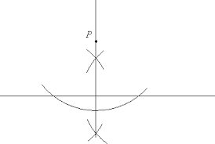
7. Perpendicular from a Point on a Line | Given line PQ and point R on the line:  1. Put the sharp point of a pair of compasses on point R.  2. Draw two arcs either side of the point of equal width (giving points S and T)  3. Place the compass on point S, open over halfway and draw an arc above the line.  4. Repeat from the other arc on the line (point T).  5. Draw a straight line from the intersecting arcs to the original point on the line. | 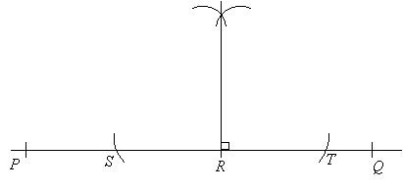
8. Constructing Triangles (Side, Side, Side) | 1. Draw the base of the triangle using a ruler.  2. Open a pair of compasses to the width of one side of the triangle.  3. Place the point on one end of the line and draw an arc.  4. Repeat for the other side of the triangle at the other end of the line.  5. Using a ruler, draw lines connecting the ends of the base of the triangle to the point where the arcs intersect.
9. Constructing Triangles (Side, Angle, Side) | 1. Draw the base of the triangle using a ruler.  2. Measure the angle required using a protractor and mark this angle.  3. Remove the protractor and draw a line of the exact length required in line with the angle mark drawn.  4. Connect the end of this line to the other end of the base of the triangle.
10. Constructing Triangles (Angle, Side, Angle) | 1. Draw the base of the triangle using a ruler.  2. Measure one of the angles required using a protractor and mark this angle.  3. Draw a straight line through this point from the same point on the base of the triangle.  4. Repeat this for the other angle on the other end of the base of the triangle.
11. Constructing an Equilateral Triangle (also makes a 60° angle) | 1. Draw the base of the triangle using a ruler.  2. Open the pair of compasses to the exact length of the side of the triangle.  3. Place the sharp point on one end of the line and draw an arc.  4. Repeat this from the other end of the line.  5. Using a ruler, draw lines connecting the ends of the base of the triangle to the point where the arcs intersect. | 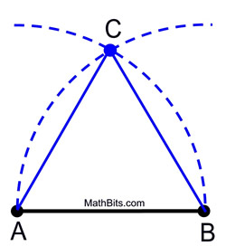
12. Loci and Regions | A locus is a path of points that follow a rule.  For the locus of points closer to B than A, create a perpendicular bisector between A and B and shade the side closer to B.  For the locus of points equidistant from A, use a compass to draw a circle, centre A.  For the locus of points equidistant to line X and line Y, create an angle bisector.  For the locus of points a set distance from a line, create two semi-circles at either end joined by two parallel lines. | 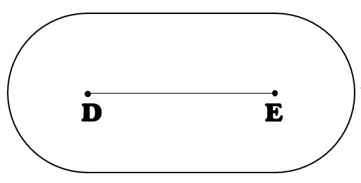
13. Equidistant | A point is equidistant from a set of objects if the distances between that point and each of the objects is the same. | 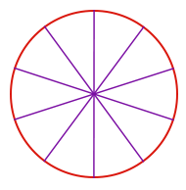

Knowledge Organiser

