Topic/Skill | Definition/Tips | Example  Topic: Congruence and Similarity
1. Congruent Shapes | Shapes are congruent if they are identical - same shape and same size.  Shapes can be rotated or reflected but still be congruent. | 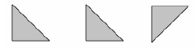
2. Congruent Triangles | 4 ways of proving that two triangles are congruent:  1. SSS (Side, Side, Side)  2. RHS (Right angle, Hypotenuse, Side)  3. SAS (Side, Angle, Side)  4. ASA (Angle, Side, Angle) or AAS  ASS does not prove congruency. | 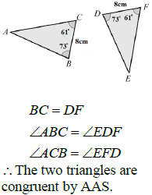
3. Similar Shapes | Shapes are similar if they are the same shape but different sizes.  The proportion of the matching sides must be the same, meaning the ratios of corresponding sides are all equal. | 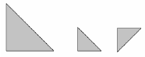
4. Scale Factor | The ratio of corresponding sides of two similar shapes.  To find a scale factor, divide a length on one shape by the corresponding length on a similar shape. | 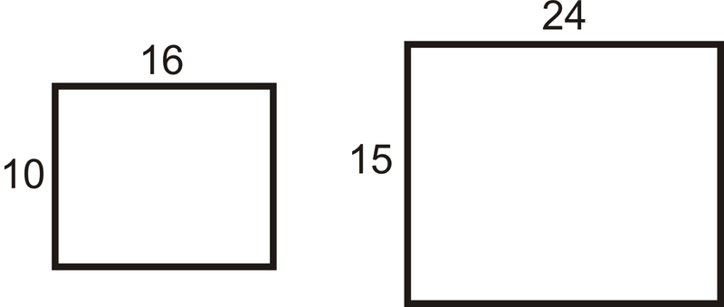  Scale Factor = $15÷10=1.5$
5. Finding missing lengths in similar shapes | 1. Find the scale factor.  2. Multiply or divide the corresponding side to find a missing length.  If you are finding a missing length on the larger shape you will need to multiply by the scale factor.  If you are finding a missing length on the smaller shape you will need to divide by the scale factor. | 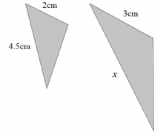  Scale Factor = $3÷2=1.5$  $x=4.5×1.5=6.75cm$
6. Similar Triangles | To show that two triangles are similar, show that:  1. The three sides are in the same proportion  2. Two sides are in the same proportion, and their included angle is the same  3. The three angles are equal

Knowledge Organiser

