Topic/Skill | Definition/Tips | Example  Topic: Representing Data
1. Frequency Table | A record of how often each value in a set of data occurs. | 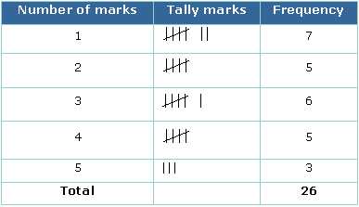
2. Bar Chart | Represents data as vertical blocks.  $x-axis$ shows the type of data  $y-axis$ shows the frequency for each type of data  Each bar should be the same width  There should be gaps between each bar  Remember to label each axis. | 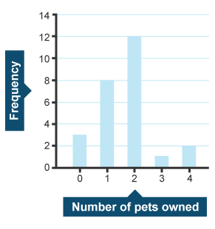
3. Types of Bar Chart | Compound/Composite Bar Charts show data stacked on top of each other.  Comparative/Dual Bar Charts show data side by side. | 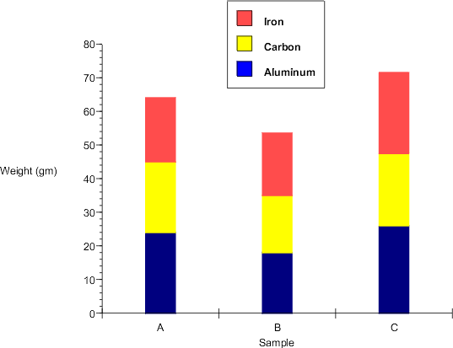  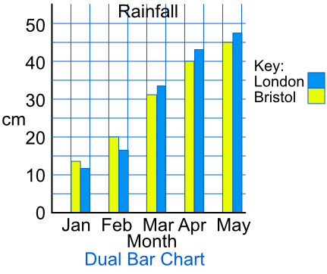
4. Pie Chart | Used for showing how data breaks down into its constituent parts.  When drawing a pie chart, divide 360° by the total frequency. This will tell you how many degrees to use for the frequency of each category.  Remember to label the category that each sector in the pie chart represents. | If there are 40 people in a survey, then each person will be worth 360÷40=9° of the pie chart.
5. Pictogram | Uses pictures or symbols to show the value of the data.  A pictogram must have a key. | 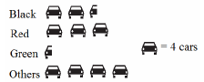
6. Line Graph | A graph that uses points connected by straight lines to show how data changes in values.  This can be used for time series data, which is a series of data points spaced over uniform time intervals in time order. | 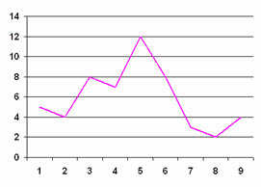
7. Two Way Tables | A table that organises data around two categories.  Fill out the information step by step using the information given.  Make sure all the totals add up for all columns and rows. | 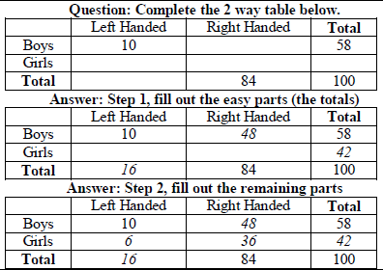
8. Box Plots | The minimum, lower quartile, median, upper quartile and maximum are shown on a box plot.  A box plot can be drawn independently or from a cumulative frequency diagram. | Students sit a maths test. The highest score is 19, the lowest score is 8, the median is 14, the lower quartile is 10 and the upper quartile is 17. Draw a box plot to represent this information.  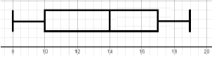
9. Comparing Box Plots | Write two sentences.  1. Compare the averages using the medians for two sets of data.  2. Compare the spread of the data using the range or IQR for two sets of data.  The smaller the range/IQR, the more consistent the data.  You must compare box plots in the context of the problem. | ‘On average, students in class A were more successful on the test than class B because their median score was higher.’  ‘Students in class B were more consistent than class A in their test scores as their IQR was smaller.’

Knowledge Organiser

