Topic/Skill | Definition/Tips | Example  Topic: Summarising Data
1. Types of Data | Qualitative Data – non-numerical data  Quantitative Data – numerical data  Continuous Data – data that can take any numerical value within a given range.  Discrete Data – data that can take only specific values within a given range. | Qualitative Data – eye colour, gender etc.  Continuous Data – weight, voltage etc.  Discrete Data – number of children, shoe size etc.
2. Grouped Data | Data that has been bundled in to categories.  Seen in grouped frequency tables, histograms, cumulative frequency etc. | 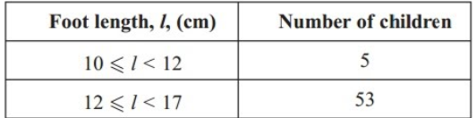
3. Primary /Secondary Data | Primary Data – collected yourself for a specific purpose.  Secondary Data – collected by someone else for another purpose. | Primary Data – data collected by a student for their own research project.  Secondary Data – Census data used to analyse link between education and earnings.
4. Mean | Add up the values and divide by how many values there are. | The mean of 3, 4, 7, 6, 0, 4, 6 is  $$\frac{3+4+7+6+0+4+6}{7}=5$$
5. Mean from a Table | 1. Find the midpoints (if necessary)  2. Multiply Frequency by values or midpoints  3. Add up these values  4. Divide this total by the Total Frequency  If grouped data is used, the answer will be an estimate. | 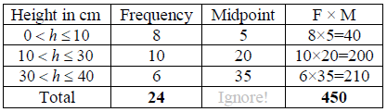  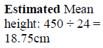
6. Median Value | The middle value.  Put the data in order and find the middle one.  If there are two middle values, find the number half way between them by adding them together and dividing by 2. | Find the median of: 4, 5, 2, 3, 6, 7, 6  Ordered: 2, 3, 4, 5, 6, 6, 7  Median = 5
7. Median from a Table | Use the formula $\frac{(n+1)}{2}$ to find the position of the median.  $n$ is the total frequency. | If the total frequency is 15, the median will be the $\left(\frac{15+1}{2}\right)=8th$position
8. Mode /Modal Value | Most frequent/common.  Can have more than one mode (called bi-modal or multi-modal) or no mode (if all values appear once) | Find the mode: 4, 5, 2, 3, 6, 4, 7, 8, 4  Mode = 4
9. Range | Highest value subtract the Smallest value  Range is a ‘measure of spread’. The smaller the range the more consistent the data. | Find the range: 3, 31, 26, 102, 37, 97.  Range = 102-3 = 99
10. Outlier | A value that ‘lies outside’ most of the other values in a set of data.  An outlier is much smaller or much larger than the other values in a set of data. | 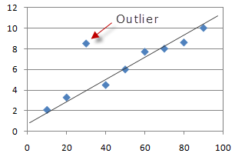
11. Lower Quartile | Divides the bottom half of the data into two halves.  LQ = $Q_{1}=\frac{(n+1)}{4}th$value | Find the lower quartile of: 2, 3, 4, 5, 6, 6, 7  $Q_{1}=\frac{(7+1)}{4}=2nd$value 3
12. Lower Quartile | Divides the top half of the data into two halves.  UQ = $Q_{3}=\frac{3(n+1)}{4}th$value | Find the upper quartile of: 2, 3, 4, 5, 6, 6, 7  $Q_{3}=\frac{3(7+1)}{4}=6th$value 6
13. Interquartile Range | The difference between the upper quartile and lower quartile.  $$IQR=Q_{3}-Q_{1}$$  The smaller the interquartile range, the more consistent the data. | Find the IQR of: 2, 3, 4, 5, 6, 6, 7  $$IQR=Q_{3}-Q_{1}=6-3=3$$

Knowledge Organiser

