Topic/Skill | Definition/Tips | Example  Topic: Pythagoras’ Theorem
1. Pythagoras’ Theorem | For any right angled triangle:  $$a^{2}+b^{2}=c^{2}$$  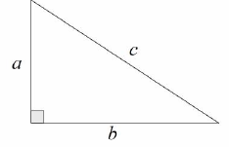  Used to find missing lengths.  a and b are the shorter sides, c is the hypotenuse (longest side). | 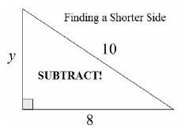  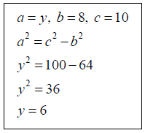
2. 3D Pythagoras’ Theorem | Find missing lengths by identifying right angled triangles.  You will often have to find a missing length you are not asked for before finding the missing length you are asked for. | Can a pencil that is 20cm long fit in a pencil tin with dimensions 12cm, 13cm and 9cm? The pencil tin is in the shape of a cuboid.  Hypotenuse of the base = $\sqrt{{12}^{2}+{13}^{2}}=17.7$  Diagonal of cuboid = $\sqrt{{17.7}^{2}+9^{2}}=19.8cm$  No, the pencil cannot fit.

Knowledge Organiser

