Topic/Skill | Definition/Tips | Example  Topic: Properties of Polygons
1. Square | - Four equal sides  - Four right angles  - Opposite sides parallel  - Diagonals bisect each other at right angles  - Four lines of symmetry  - Rotational symmetry of order four | 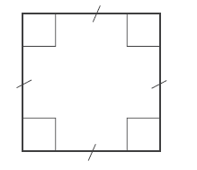
2. Rectangle | • Two pairs of equal sides  • Four right angles  • Opposite sides parallel  • Diagonals bisect each other, not at right angles  • Two lines of symmetry  • Rotational symmetry of order two | 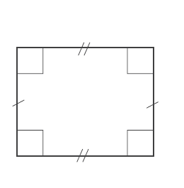
3. Rhombus | • Four equal sides  • Diagonally opposite angles are equal  • Opposite sides parallel  • Diagonals bisect each other at right angles  • Two lines of symmetry  • Rotational symmetry of order two
4. Parallelogram | • Two pairs of equal sides  • Diagonally opposite angles are equal  • Opposite sides parallel  • Diagonals bisect each other, not at right angles  • No lines of symmetry  • Rotational symmetry of order two | 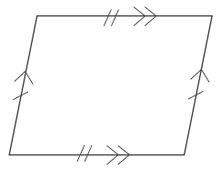
5. Kite | • Two pairs of adjacent sides of equal length  • One pair of diagonally opposite angles are equal (where different length sides meet)  • Diagonals intersect at right angles, but do not bisect  • One line of symmetry  • No rotational symmetry
6. Trapezium | - One pair of parallel sides  - No lines of symmetry  - No rotational symmetry  Special Case: Isosceles Trapeziums have one line of symmetry. | 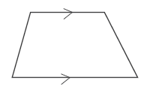

Knowledge Organiser

