Topic/Skill | Definition/Tips | Example  Topic: Bearings and Scale Diagrams
1. Scale | The ratio of the length in a model to the length of the real thing. | 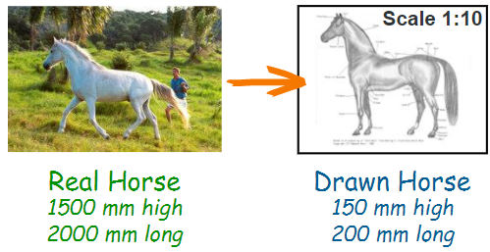
2. Scale (Map) | The ratio of a distance on the map to the actual distance in real life. | 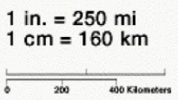
3. Bearings | 1. Measure from North (draw a North line)  2. Measure clockwise  3. Your answer must have 3 digits (eg. 047°)  Look out for where the bearing is measured from. | 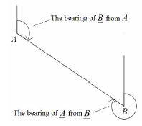
4. Compass Directions | You can use an acronym such as ‘Never Eat Shredded Wheat’ to remember the order of the compass directions in a clockwise direction.  Bearings: $NE=045°, W=270° etc.$ | 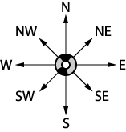

Knowledge Organiser

