Topic/Skill | Definition/Tips | Example  Topic: Angles
1. Types of Angles | Acute angles are less than 90°.  Right angles are exactly 90°.  Obtuse angles are greater than 90° but less than 180°.  Reflex angles are greater than 180° but less than 360°. | 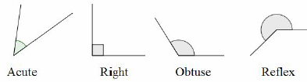
2. Angle Notation | Can use one lower-case letters, eg. $θ$ or $x$  Can use three upper-case letters, eg. $BAC$ | 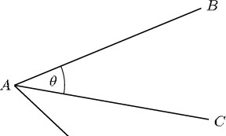
3. Angles at a Point | Angles around a point add up to 360°. | 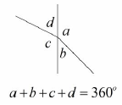
4. Angles on a Straight Line | Angles around a point on a straight line add up to 180°. | 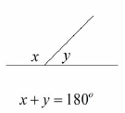
5. Opposite Angles | Vertically opposite angles are equal. | 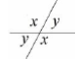
6. Alternate Angles | Alternate angles are equal.  They look like Z angles, but never say this in the exam. | 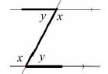
7. Corresponding Angles | Corresponding angles are equal.  They look like F angles, but never say this in the exam. | 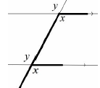
8. Co-Interior Angles | Co-Interior angles add up to 180°.  They look like C angles, but never say this in the exam. | 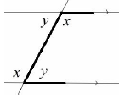
9. Angles in a Triangle | Angles in a triangle add up to 180°. | 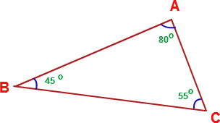
10. Types of Triangles | Right Angle Triangles have a 90° angle in.  Isosceles Triangles have 2 equal sides and 2 equal base angles.  Equilateral Triangles have 3 equal sides and 3 equal angles (60°).  Scalene Triangles have different sides and different angles.  Base angles in an isosceles triangle are equal. | 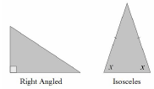  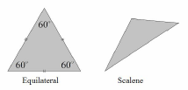
11. Angles in a Quadrilateral | Angles in a quadrilateral add up to 360°.
12. Polygon | A 2D shape with only straight edges. | Rectangle, Hexagon, Decagon, Kite etc.
13. Regular | A shape is regular if all the sides and all the angles are equal.
14. Names of Polygons | 3-sided = Triangle  4-sided = Quadrilateral  5-sided = Pentagon  6-sided = Hexagon  7-sided = Heptagon/Septagon  8-sided = Octagon  9-sided = Nonagon  10-sided = Decagon | 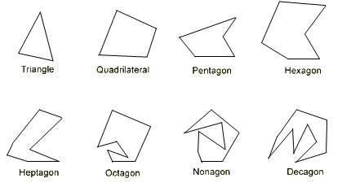
15. Sum of Interior Angles | $$(n-2)×180$$  where n is the number of sides. | Sum of Interior Angles in a Decagon = $\left(10-2\right)×180=1440°$
16. Size of Interior Angle in a Regular Polygon | $$\frac{(n-2)×180}{n}$$  You can also use the formula:  $$180-Size of Exterior Angle$$ | Size of Interior Angle in a Regular Pentagon =  $$\frac{(5-2)×180}{5}=108°$$
17. Size of Exterior Angle in a Regular Polygon | $$\frac{360}{n}$$  You can also use the formula:  $$180-Size of Interior Angle$$ | Size of Exterior Angle in a Regular Octagon =  $$\frac{360}{8}=45°$$

Knowledge Organiser

