Topic/Skill | Definition/Tips | Example  Topic: Proportion
1. Direct Proportion | If two quantities are in direct proportion, as one increases, the other increases by the same percentage.  If $y$ is directly proportional to $x$, this can be written as $y ∝ x$  An equation of the form $y=kx$represents direct proportion, where $k$ is the constant of proportionality. | 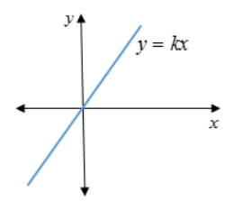
2. Inverse Proportion | If two quantities are inversely proportional, as one increases, the other decreases by the same percentage.  If $y$ is inversely proportional to $x$, this can be written as $y ∝\frac{1}{x}$  An equation of the form $y=\frac{k}{x}$ represents inverse proportion. | 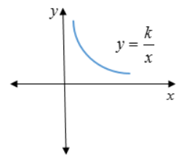
3. Using proportionality formulae | Direct: y = kx or y$∝$x  Inverse: y = $\frac{k}{x}$ or y $∝$ $\frac{1}{x}$  1. Solve to find k using the pair of values in the question.  2. Rewrite the equation using the k you have just found.  3. Substitute the other given value from the question in to the equation to find the missing value. | p is directly proportional to q.  When p = 12, q = 4.  Find p when q = 20.  1. p = kq  12 = k x 4  so k = 3  2. p = 3q  3. p = 3 x 20 = 60, so p = 60
4. Direct Proportion with powers | Graphs showing direct proportion can be written in the form $y=kx^{n}$  Direct proportion graphs will always start at the origin. | 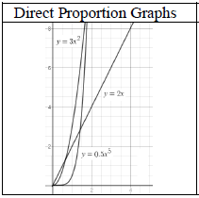
5. Inverse Proportion with powers | Graphs showing inverse proportion can be written in the form $y=\frac{k}{x^{n}}$  Inverse proportion graphs will never start at the origin. | 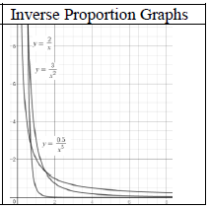

Knowledge Organiser

