Topic/Skill | Definition/Tips | Example  Topic: Ratio
1. Ratio | Ratio compares the size of one part to another part.  Written using the ‘:’ symbol. | 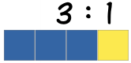
2. Proportion | Proportion compares the size of one part to the size of the whole.  Usually written as a fraction. | In a class with 13 boys and 9 girls, the proportion of boys is $\frac{13}{22}$ and the proportion of girls is $\frac{9}{22}$
3. Simplifying Ratios | Divide all parts of the ratio by a common factor. | 5 : 10 = 1 : 2 (divide both by 5)  14 : 21 = 2 : 3 (divide both by 7)
4. Ratios in the form $1 : n$ or $n : 1$ | Divide both parts of the ratio by one of the numbers to make one part equal 1. | 5 : 7 = 1 : $\frac{7}{5}$ in the form 1 : n  5 : 7 = $\frac{5}{7}$ : 1 in the form n : 1
5. Sharing in a Ratio | 1. Add the total parts of the ratio.  2. Divide the amount to be shared by this value to find the value of one part.  3. Multiply this value by each part of the ratio.  Use only if you know the total. | Share £60 in the ratio 3 : 2 : 1.  3 + 2 + 1 = 6  60 ÷ 6 = 10  3 x 10 = 30, 2 x 10 = 20, 1 x 10 = 10  £30 : £20 : £10
6. Proportional Reasoning | Comparing two things using multiplicative reasoning and applying this to a new situation.  Identify one multiplicative link and use this to find missing quantities. | 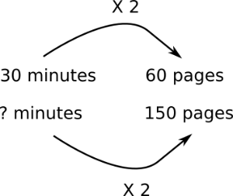
7. Unitary Method | Finding the value of a single unit and then finding the necessary value by multiplying the single unit value. | 3 cakes require 450g of sugar to make. Find how much sugar is needed to make 5 cakes.  3 cakes = 450g  So 1 cake = 150g (÷ by 3)  So 5 cakes = 750 g (x by 5)
8. Ratio already shared | Find what one part of the ratio is worth using the unitary method. | Money was shared in the ratio 3:2:5 between Ann, Bob and Cat. Given that Bob had £16, found out the total amount of money shared.  £16 = 2 parts  So £8 = 1 part  3 + 2 + 5 = 10 parts, so 8 x 10 = £80
9. Best Buys | Find the unit cost by dividing the price by the quantity.  The lowest number is the best value. | 8 cakes for £1.28 16p each (÷by 8)  13 cakes for £2.05 15.8p each (÷by 13)  Pack of 13 cakes is best value.

Knowledge Organiser

