Topic/Skill | Definition/Tips | Example  Topic: Perimeter and Area
1. Perimeter | The total distance around the outside of a shape.  Units include: $mm, cm, m$etc. | 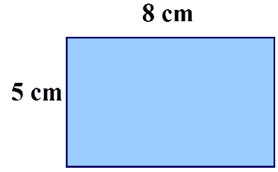  $P=8+5+8+5=26cm$
2. Area | The amount of space inside a shape.  Units include: $mm^{2}, cm^{2}, m^{2}$ | 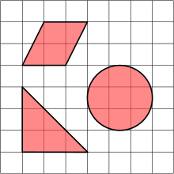
3. Area of a Rectangle | Length x Width | $A=36cm^{2}$
4. Area of a Parallelogram | Base x Perpendicular Height  Not the slant height. | $A=21cm^{2}$
5. Area of a Triangle | Base x Height ÷ 2 | 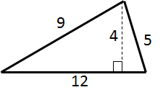$A=24cm^{2}$
6. Area of a Kite | Split in to two triangles and use the method above. | 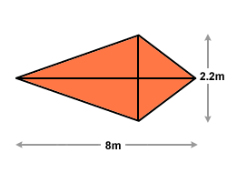 $A=8.8m^{2}$
7. Area of a Trapezium | $$\frac{(a+b)}{2}×h$$  “Half the sum of the parallel side, times the height between them. That is how you calculate the area of a trapezium” | 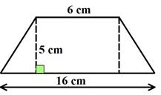 $A=55cm^{2}$
8. Compound Shape | A shape made up of a combination of other known shapes put together. | 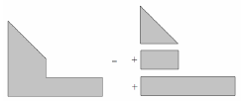

Knowledge Organiser

