**Surds Task 1**

1

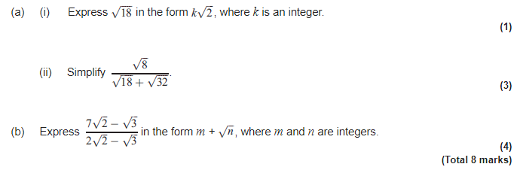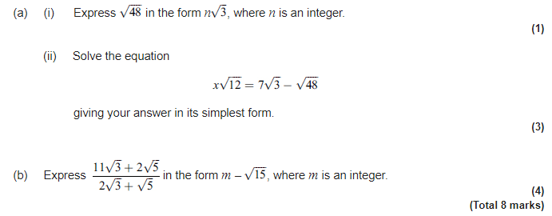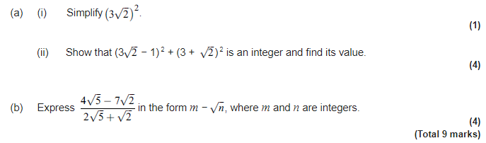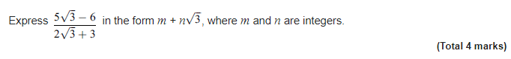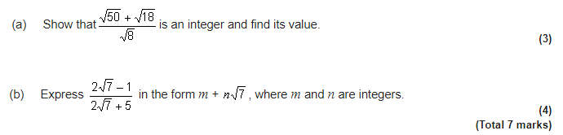

5

4

3

2